Names:________________________________________
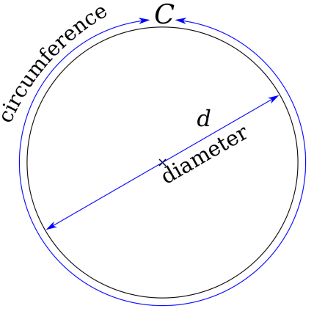
Forward and Back
Rotation – rotation is the complete movement of an object around an axis. For our robots, the wheels of the robot rotate.
Diameter – the distance across the center of a circle.
Circumference- distance around the circle.

- How far will a wheel travel in one rotation, the circumference or the diameter? If you are unsure, test it.

- Describe how you can measure the circumference of a circle.

- Using centimeters, measure the circumference of the robot’s tire.

- How far will the robot move on a single rotation?

- How would you calculate how many rotations it would take to travel a specific distance?

- Fill out the table below
 | Estimate the number of rotations | Calculated Answer
Forward 40 cm
Forward 60 cm
Backward 60 cm
Forward 10 cm

Turns
Spin Turn – a turn where the robot spins in place. Both motors turn the same, but in opposite directions.
Pivot Turn – a turn where only one motor rotates. The other stays still, and the robot’s body moves with the turn.
Angle – the change in the direction that the robot is facing. Usually measured in degrees.

Pivot Turns
- Position your robot pointing away from you. Rotate the left wheel forward one rotation while keeping the right wheel in place. How did the angle of the robot change?

- Position your robot the same way as in question 7, but rotate the left wheel forward two rotations. How did the angle of the robot change?

- Position your robot the same way as in question 7, but rotate the left wheel backwards 1 rotation. How did the angle of the robot change?

Spin Turns
- Position your robot the same way as in question 7. This time, you will rotate the left wheel forward one rotation, at the same time as the right wheel backwards one rotation. How did the angle of the robot change?

- Position your robot the same way as in question 7. Rotate the left wheel forward ½ of a rotation while rotating the right wheel backward ½ of a rotation. How did the angle of the robot change?

