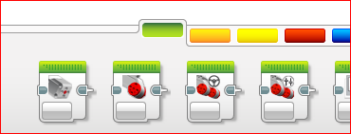
Action bar
This is where you program the robot to do thing (as opposed to sense things or to do math, etc).
From Left to Right:
- Medium Motor
- Single Large Motor
- Move Steering Block (two motors)
- Move Tank Block (two motors)
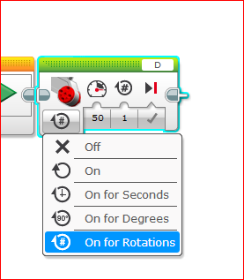
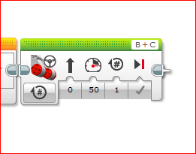
The controls are basically the same for all the motors… Move Steering is used as an example.
From Left to Right:
- Mode - See right
- Steering (0 is straight ahead, 50 or -50 pivot on a wheel, -100 or 100 one wheel rotates forward while the other rotates backwards)
- Power – Speed. High speed is less accurate but faster (best for returning to base!)
- Number of Rotations (in this mode)
- Type of breaking- On by default and this is ok.
Up above, you see which motors are controlled by this block. Hint: Try to keep B as the left motor and C as the right motor for driving and you won’t have to keep changing it!
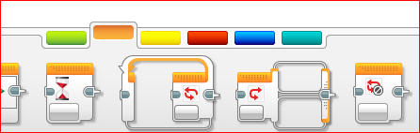
Hint: Stalls… if a motor is set to go for a certain number of degrees or rotations but cannot complete the motion (ie, hitting something) the program will not be able to continue. If possible, go for a certain number of seconds.
Flow Control bar
These commands control the order and timing of thingsFrom Left to Right
- Start
- Wait
- Loop
- Switch
- Loop Interrupt
Start… you can have multiple lines of code running at the same time. This is just one of many ways of achieving that.
Wait is just that… it pauses everything in your program. Can be triggered by more than time.
Loops causes the robot to repeat an action (or to keep doing an action) for a certain time, number of loops, or trigger occurs.
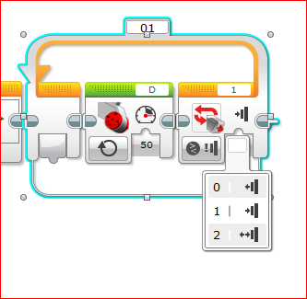
Switches are like if-then statements. If your room is clean, then you can have a snack, etc.
To the Left is an example of the Loop: The large motor connected to D will continue forward at 50 power until the touch sensor (plugged into port #1) is pressed.
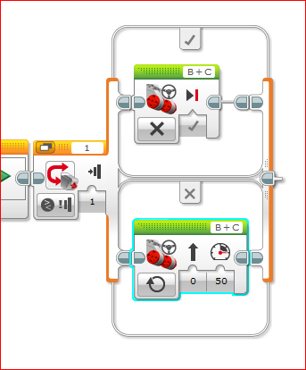

To the right is an example of the Switch: If the Touch Sensor is Pressed, then stop motors B and C. If not, then B and C will continue forward.
NOTE: Switches will not loop unless inside of a loop! The example above will only check once.
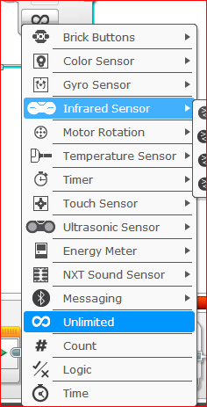
Triggers and Sensors– as shown above, you can use triggers in a variety of places. Below is the list of triggers you can use.

Main ones
- Touch –
- Color – senses the light reflected off the table. Useful for positioning
- Gyro – senses the angle of turns… hard to use - avoid
- Ultrasonic Sensor – measures distance using sound. Can be tricked by noise - avoid

